





**Purpose & Aims**

**2021/2022**

**Alpha Academies Trust**

**Contents**

**Strategic Ambition1/2**

**Our Academies2**

**Unlocking big strategic moves3**

**2025 Aims4**

**What We Aim to Achieve 2021 - 20225**

**Governance6**

**School Improvement7/8/9**

Improvement Cycle7

Audit and Analysis8

Plan and Implement9

**Alpha Academies Trust Capacity to Support10**

**Growth Maps11/12**

**All Central Services13/14**

**Academy Card15**





Page 1

**Our Strategic Ambition**



Page 2

**Our Academies**

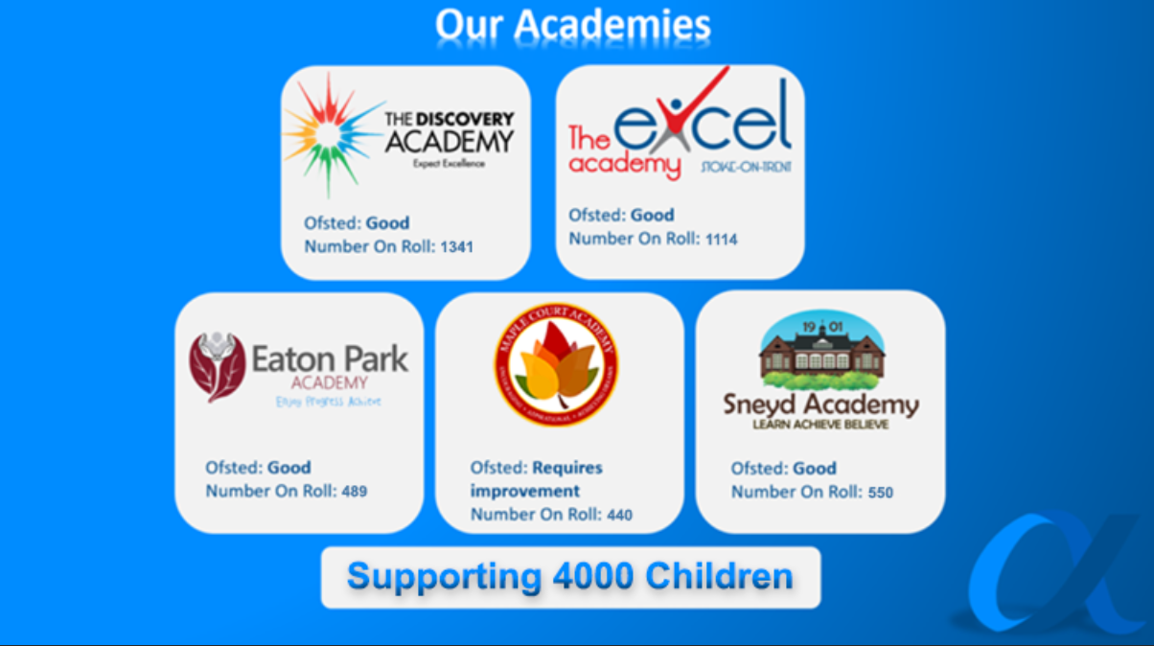

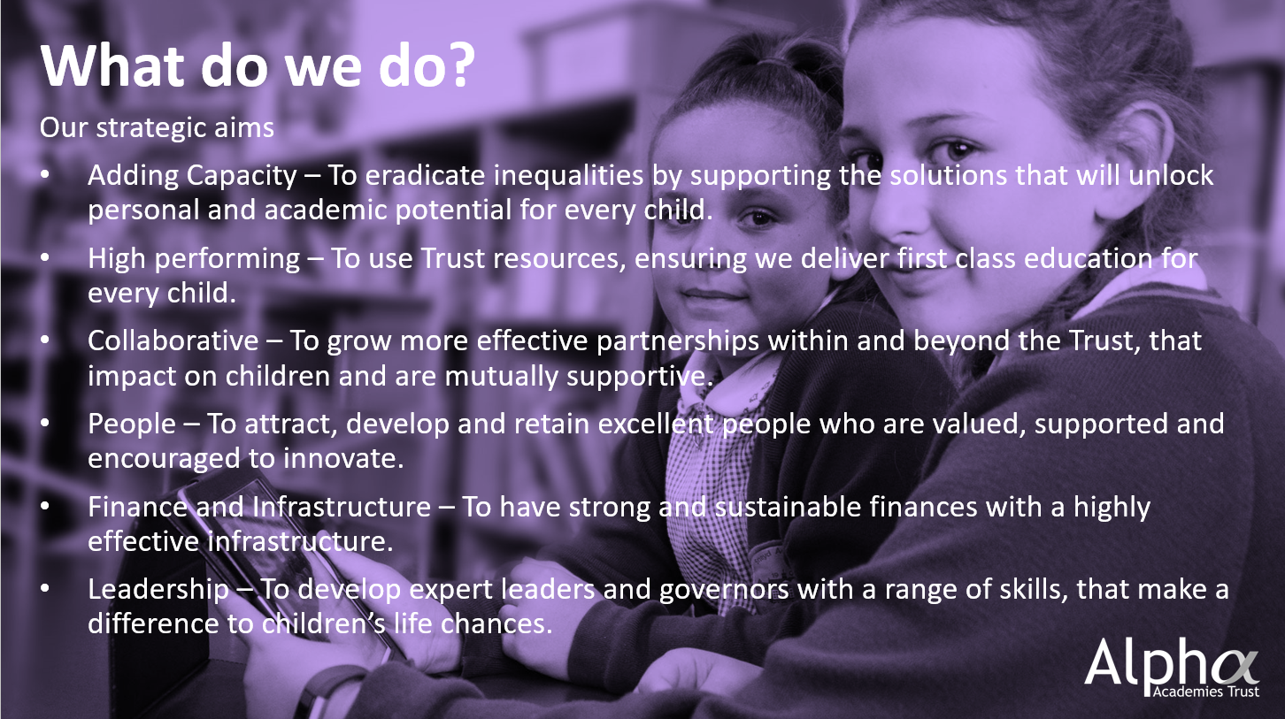



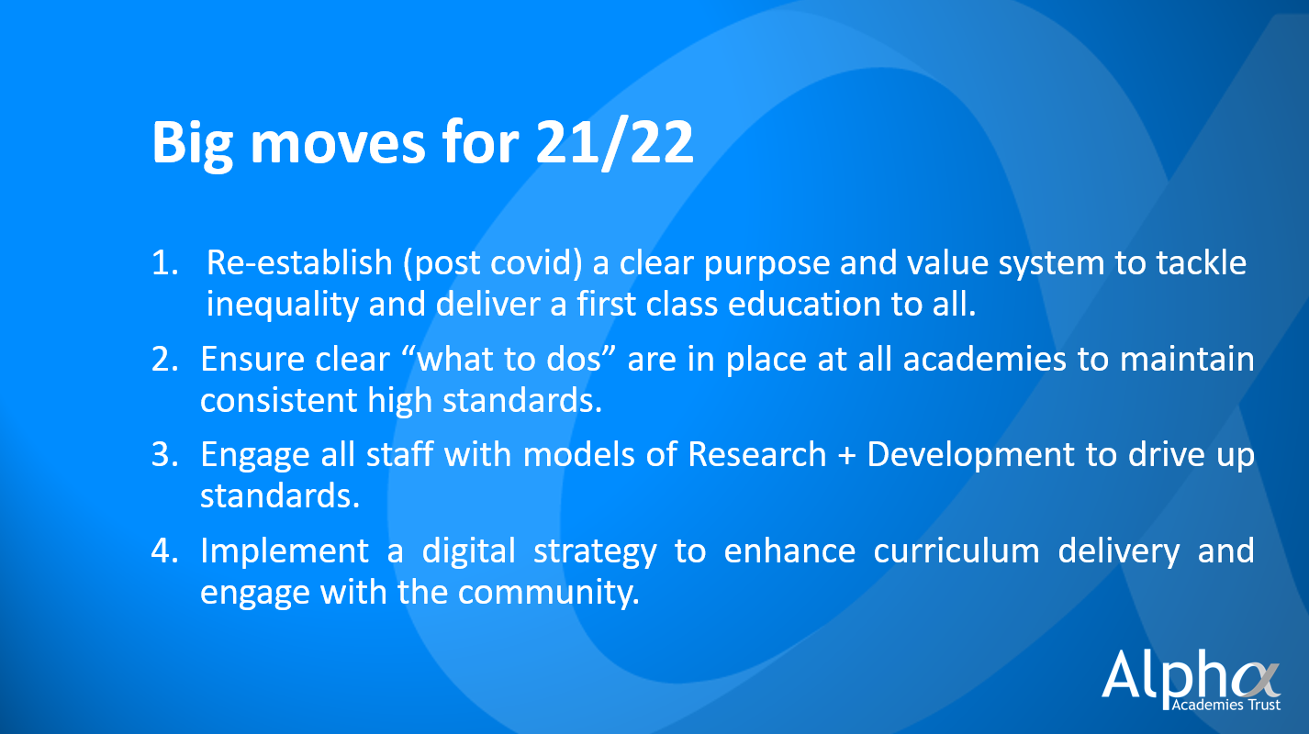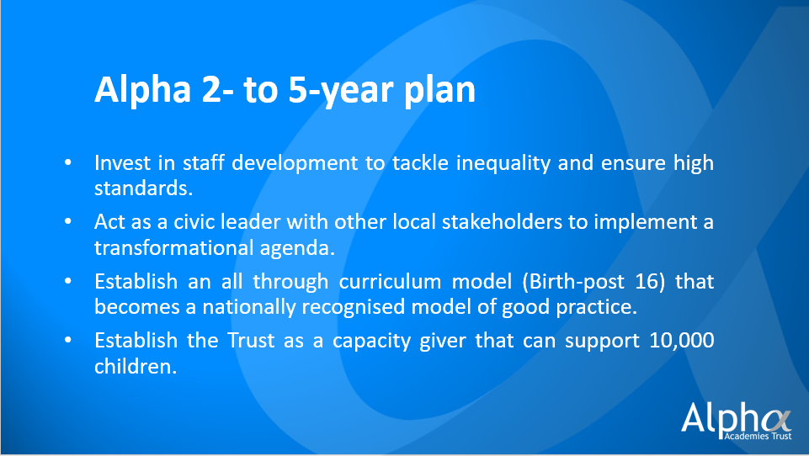

Page 3

Page 3

**2025 Aims**

Page 4

**Adding Capacity:** To support the solutions that will unlock personal and academic potential for every child.

* Academies within the Trust achieve good outcomes for all children (including disadvantaged children who are comparable to non-disadvantaged nationally)
* All children move on to positive destinations
* Primary & Secondary hubs are nationally recognised for their all-through provision/curriculum with strengthened partnership with parents and community stakeholders
* The Trust supports over 5000 students

**Finance and Infrastructure:** To have strong and sustainable finances with a highly effective infrastructure.

* Budgets always operate above 5% reserves
* Outstanding back-office support
* Digital technologies are invested in with a comprehensive strategy that impacts on teaching and working practices
* Clear policies are proven to be effective that can be used in school to school support

**High Performing:** To use Trust resources, ensuring we deliver first class education for every child.

* The school improvement strategy ensures at least two academies within the Trust are judged outstanding, with all academies that have been part of the trust for at least three years judged good
* The best leaders to support internal school improvement are recruited and developed
* The Trust invests in research and development with expert partners and becomes a research hub that innovates

**Collaborative:** To grow more effective partnerships within and beyond the Trust, that impact on children and are mutually supportive.

* Networks within the Trust add value to:
  + Curriculum development
  + Teaching and innovation
  + Inclusion and Safeguarding
  + Character development
  + Careers and cultural capital
* The Trust is an active civic leader and works with local stakeholders to lead the strategic direction for the area

**People:** To attract, develop and retain excellent people who are valued, supported and encouraged to innovate.

* The Trust workload and wellbeing strategy supports all stakeholders feeling valued with feedback that is acted upon
* Talent development involves outstanding ITT/ECF provision and a comprehensive staff development entitlement that retains and attracts the best practitioners
* Stakeholders and the community value the Trust that has a strong reputation

**Leadership:** To develop expert leaders and governors with a range of skills, that make a difference to children’s life chances.

* Strong leadership meets clearly accountable targets and is supported by a comprehensive leadership programme
* There is effective governance with a range of skill sets
* Leaders collaborate across the Trust to inform the future strategic direction

**What We Aim to Achieve 2021 - 2022**

**Adding Capacity:** To support the solutions that will unlock personal and academic potential for every child.

* After a significant disruption in education, a clear purpose is established across the Trust to deliver first class education for every child.
* Consistent values and behaviours are demonstrated by all staff, to deliver the Trust/Academy purpose.
* Plans are established that develop all through provision in areas such as curriculum, SEND and pre school provision.
* Full engagement with the Local Authority and other stakeholders supports delivery of the improving education strategy.
* Growth plans at Excel and Discovery continue to be delivered with regular risk updates reported to Trust Board.

**Finance and Infrastructure:** To have strong and sustainable finances with a highly effective infrastructure.

* Manage numerous capital projects.
* Ensure student numbers are sustainable with action taken to ensure no structural budget deficit.
* The implementation of the Digital strategy starts to enable key priorities and more effective working practices.
* Consistent educational procedures “what to dos” are implemented at each academy and deliver consistent high standards.

**Collaborative:** To grow more effective partnerships within and beyond the Trust, that impacts on children and are mutually supportive.

* Learning networks across the Trust meet clear success criteria to share good practice and support academies meeting their goals.
* Partnerships with other schools and local Trusts shares capacity and drives forward the local strategy.
* Partnership with the Newcastle under Lyme school develops joint initiatives with the independent sector.
* Partnership with Stoke sixth form and other digital providers supports the Trust digital strategy.

**High Performing:** To use Trust resources, ensuring we deliver first class education for every child.

* All academies ensure appropriate catch-up post covid, with return to normal/effective operations.
* Trust school improvement intervention in tier 2+3 academies ensures all academies are securely good.
* Tier 1 Academies are supported to establish outstanding provision in all areas by Sept 2022.
* A strategic group is established across the Trust with the aim to eradicate the disadvantaged gap by 2025.
* A research and development framework is implemented at all academies to support innovation.

**People:** To attract, develop and retain excellent people who are valued, supported and encouraged to innovate.

* Consistent feedback mechanisms that support the staff well-being strategy are expanded to include children and the community.
* Partnerships established with Chartered College of Teaching, other Trusts and the Golden Thread Teaching hub enhances the Trust staff development entitlement.
* The early career teaching policy is implemented at all academies and delivers outstanding support for early career teachers.
* The digital strategy supports better engagement with communities.

**Leadership:** To develop expert leaders and governors with a range of skills, that make a difference to children’s life chances.

* Implement a revised strategic planning model with more regular opportunities for leaders to evaluate and develop improvement plans.
* Establish a framework to evaluate leadership at each academy that is quality assured by an external NLE.
* Continue the Trust leadership development programme to support emerging leaders through to SLT and Governors.
* Appoint Members to the Trust who can act in an ambassadorial role to support the Trust reaching its ambition as a local civic leader.

Page 5



Page 6

**School Improvement: Improvement Cycle**

**School Improvement: Audit and Analysis**

Page 7

Trust Board

Inclusion and Community  
Committee

Risk Register

LGB

Standards Review

Challenge +

Improvement Sub Committee

Education Experts

Academy

Card

* ½ Termly Evaluation with Chairs
* Risk Analysis
* School Improvement Analysis

Trust Board Standards Committee

Trust Board

Page 8

**School Improvement: Plan and Implement**

**Review**The Academy card will monitor progress and this will be evaluated in the challenge group (tier 3 intervention) & LGB. Evaluation will inform further actions taken by the Trust Board.

Page 9

**Tier 1 Criteria**

Positive outcome trend

Overall effectiveness – good / outstanding

NLE reviews identify effective capacity

Low risk of school improvement failure (risk register)

**Academy Led**

Building on area of strength through innovation with results shared across the Trust.

**Trust Support**

* Commission partner to support evidenced based research and development
* Trust network group to support innovation
* Information shared through teaching and learning network / website

**Tier 2 Criteria**

Negative outcome (one year)

Overall effectiveness – good

NLE reviews identify effective capacity

Medium risk of school improvement failure (risk register)

**Academy Led**

Time limited period to implement bespoke improvement strategy. KPIs identified through academy development plan and monitored through academy card.

**Trust Support**

* Commissioned good practice school partner
* Central team deployed
* Trust network group support
* Commission additional reviews
* Trust CPD programme

**Tier 3 Criteria (Any One Descriptor)**

Negative outcomes pattern and trend beyond one year

Inadequate / RI Overall Effectiveness

NLE reviews do not identify capacity to improve

High risk of school improvement failure (risk register)

**Trust Led**

**Standardised:** The Academy will implement the Trust standardised policies that are proven, for either a specific area, or all relevant areas of the Academy’s work.

**Trust Support:**

* Whole academy external review identifies precise areas for intervention
* School to school support commissioned
* Central team coordinates implementation of standardised policies and bespoke solutions

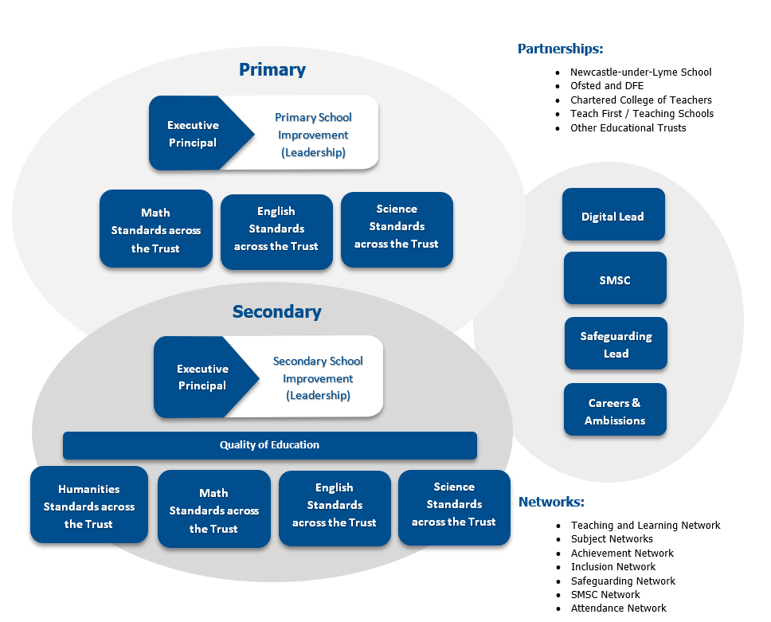**T****rust Capacity to Support**

Page 10

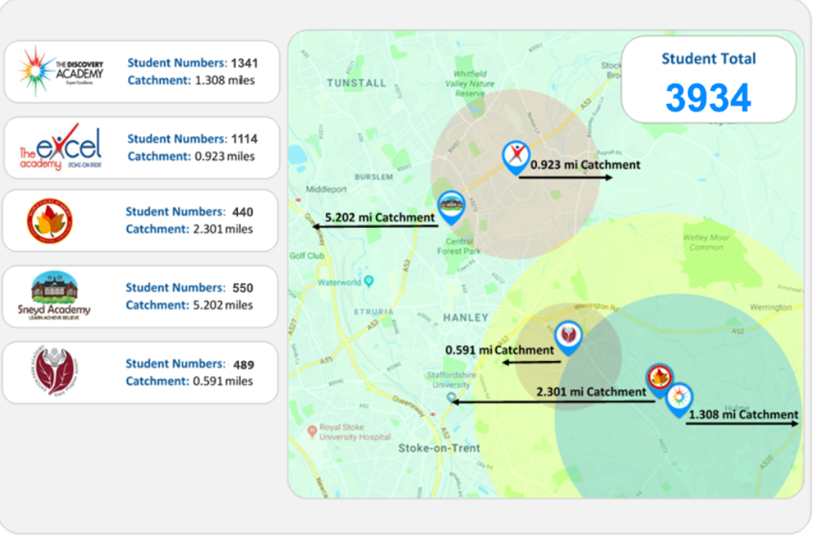**Growth Map: Present**

Page 11

**0.591 mi Catchment**

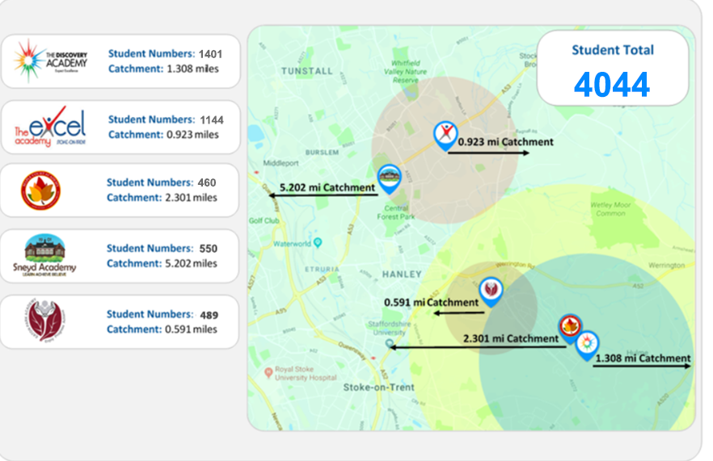**Growth Map: 2022/23**

Page 12

* Network
* Hardware
* Cloud based solutions
* Compliance
* Technology to support teaching & learning
* Website management
* Future digital technologies

**IT Infrastructure & Digital Transformation**

**All central Services**

* Annual Budget Planning
* Finance System
* Financial Benchmarking Reports
* Liaison with ESFA and RSC
* Monthly Management Accounts Outturn/Monitoring Checks
* External/Internal Audit Planning
* ESFA/ DfE returns

**Financial Management**

* Regulations
* Risk Assessments support
* Training
* Access to Health & Safety Officer
* Advice and guidance

**Health & Safety**

* Dedicated HR support
* Creative Solution Focused Resolutions
* Union Negotiations
* Bespoke In-house Training
* Advice on Staffing Structures/Salaries
* Recruitment & DBS
* Single Central Register monitoring

**Human Resources**

The Trust ensure central tracking and monitoring of all contracts in place and enables timely renewal and procurement

**Contracts Management**

Central policies in place to meet legislative requirements for educational and other legislation. Other statutory documentation eg, health and safety, data protection.

**Policies**

* Advice on Project Management
* Support for Caretakers/Managers
* Capital Procurement Support
* Efficiency Improvement Programmes
* ESFA good housekeeping

**Estates Management**

Page 13

* All academies have access to Eversheds/Stoneking, the Trust’s legal advisors via a helpline to discuss any issues/queries on areas of law that can be resolved quickly.
* Other services are also available, but may incur additional charges.

**Legal**

* SLT support on operations
* Support and guidance for administration teams
* Preparation of 3 – 5 year budget plans
* Oversight of PFI Management
* Preparation and Submission of Financial Returns
* GDPR

**Business Management**

Page 14

**Academy Card**

**(Produced by the Central Data Team as a dashboard on targets & live data in all areas)**

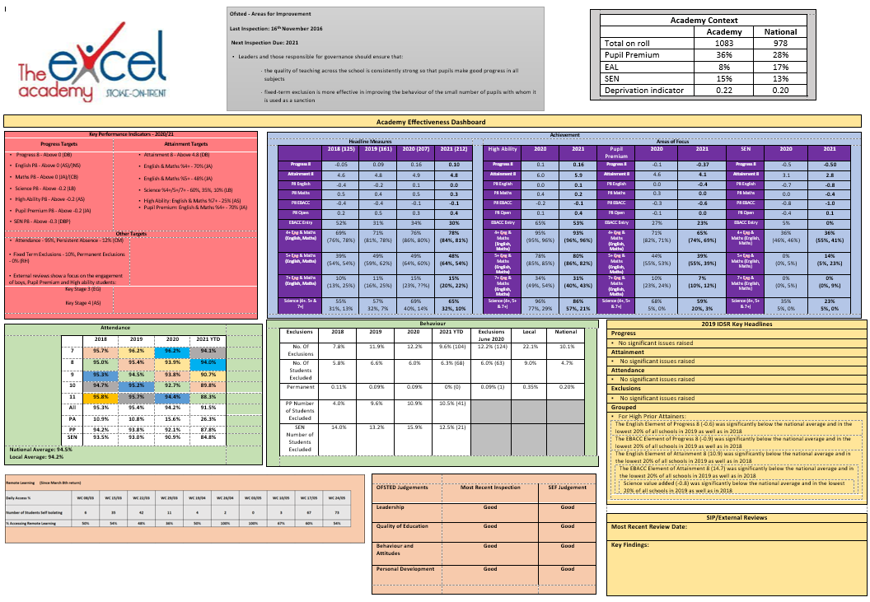

Page 15



Page 15

Page 16

Page 17